Below are the authorization groups that needs to be assigned on userID’s that will access the CPI tenants.

* ESBMessaging.send – In order to enable a sender system to process messages on a tenant using HTTPS/basic authentication.

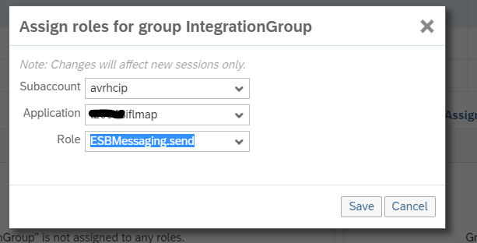

* 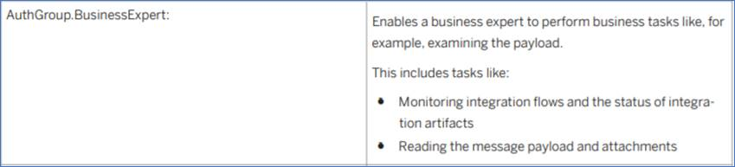
* 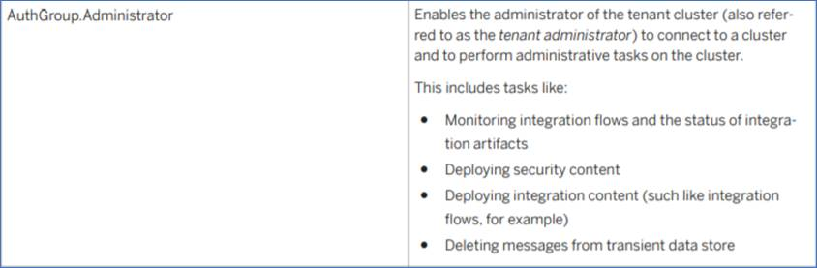
* 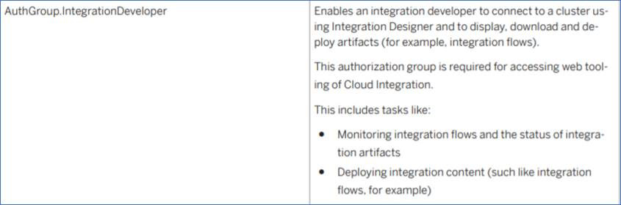

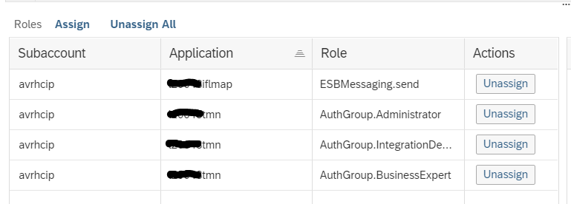

**Error:** **ESBMessaging.send role is not visible in the SAP Cloud Platform Cockpit**

**Reproducing the Issue**

1. Go to your Subscriber Account in SAP Cloud Platform Cockpit.
2. Choose Security -> Authorizations
3. Try to assign the role ESBMessaging.send to the particular user under <tenantID>iflmap Application
4. Role field is empty.

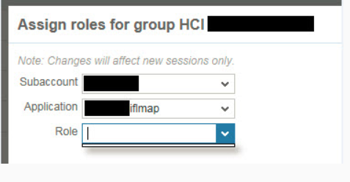

**Cause**

The iflmap node (runtime node) is not running at the moment on your tenant, hence the particular role is not available.

**Resolution**

In order to start the runtime node, please deploy at least one iFlow on it. It is designed for resource consumption.